**AUTO MOBILE SALES WITH FACTS AND DIMENSION**

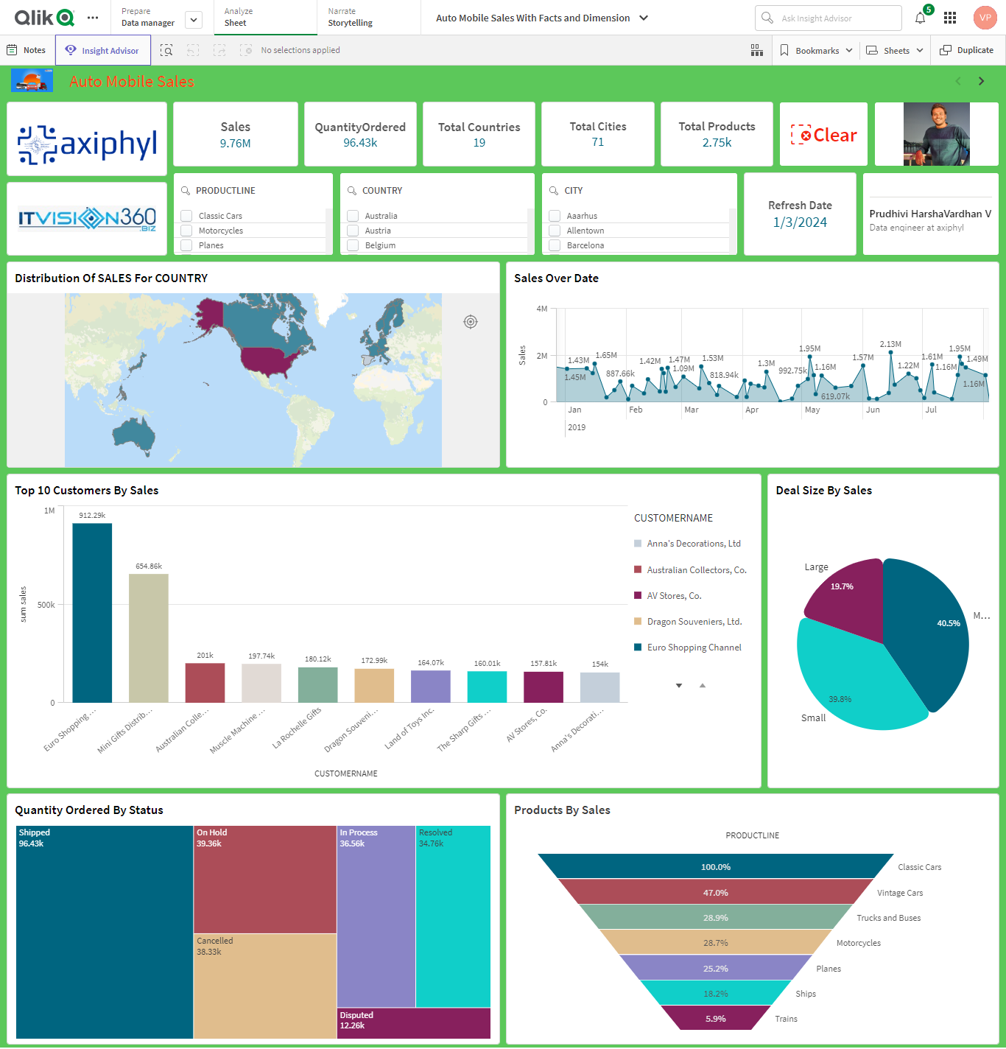

The main objective of this report is to analyse how the global automotive industry has been experiencing various trends and challenges in sales. It contains various products like cars, motorcycles, ships, and planes, the number of orders placed, and the deal of the product distribution to various countries of sale.

**Project Overview**

Data Source

Problem Statement

Key Performance Indicators (KPIs) and Data Dictionary

Executive Summary and Problems Encountered

Key Insights -Positive

Key Insights -Negative

Suggestions

Data Source

My Qlik Report consists of the following steps:

**Data collection:** Dataset has been collected from Kaggle.

**Data Preparation:** The dataset has been cleaned and processed for the analysis.

**Exploratory Data Analysis:** Data has been analysed to understand which vehicles have been sold based on different products by year.

**Data visualization:** we’ll Visualize the data to identify the Auto Mobile Sales.

**Simple Recommendation System:** Developed a visualization of sales in Auto Mobile Sales.

 Key Performance Indicators (KPIs) and Data Dictionary

Key Performance Indicators

**Sum of Sales:** Sum (Sales)

**Quantity Ordered:** Sum ([Quality Ordered])

**Total Distinct Country:** count (distinct(country))

**Total Cites:** Count (distinct CITY)

**Total Products:** sum (Products)

**Data Dictionary**

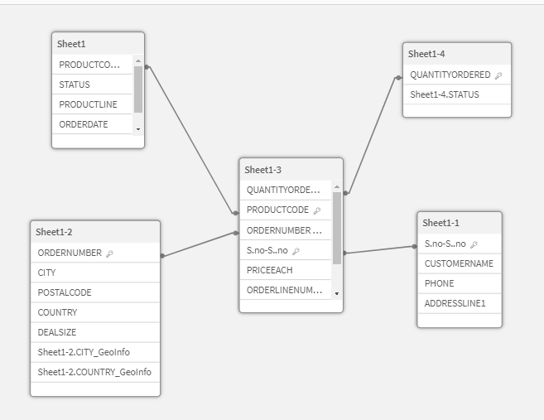

Executive Summary and Problems Encountered

The dataset contains several columns representing various attributes of Auto Mobil Sales It is divided into facts and dimensions in dimension contains city, country, Products, Orders and in facts table contain sales and prices Examining Sales and seeing any patterns or Production on Auto Mobile Sales might be part of this goal.

**Problems Encountered**

1.Choosing the correct data set was a challenge.

2.Selecting the proper KPI for the project was the other challenge. I have googled and gone through previous projects to come up with the right KPIs for the project.

3.Selecting the right KPI was the other problem occurred. MoM% was initially attempted but it does not show the desired output so there was a need to change it to YoY%.

Positive Insights:

|  |  |
| --- | --- |
| Insight | Positive |
| KPI | Total Sales |
| Good or Bad | Good |
| Responsible Dim | Genre/Year |
| More Effect Occurred | The Sales Year over Year Increased |
| Where It is Occurred | Across World |
| When the problem occurred | 2018 to 2020 |

Key Insights – Negatives

|  |  |
| --- | --- |
| Insight | Negative |
| KPI | Total Orders cancelled |
| Good or Bad | Bad |
| Responsible Dim | Genre/Year |
| Where It is Occurred | Across World |
| When the problem occurred | 2002 to 2017 |

Suggestions

Increasing automobile sales in India requires a strategic approach that considers the unique characteristics of the Indian market. Here are some suggestions for boosting automobile sales in India:

1. Understanding Local Preferences:

Analyse and understand the preferences and needs of the Indian consumers. Consider factors such as fuel efficiency, affordability, maintenance costs, and suitability for local driving conditions.

1. Affordable Models and Financing Options:

Introduce affordable models that cater to the price-sensitive Indian market. Additionally, offer attractive financing options and low-down payment plans to make vehicles more accessible to a larger audience.

1. Online Presence and Digital Marketing:

Strengthen your online presence through a user-friendly website and active social media channels. Utilize digital marketing strategies to reach a wider audience, including targeted advertising, social media campaigns, and search engine optimization.

1. Green and Electric Vehicles:

Given the increasing environmental concerns, consider introducing more electric and hybrid vehicle options. Offer incentives for electric vehicle purchases, and promote the environmental benefits of such vehicles.